

***E-Books.com***

**E-Project Documentation**

**Teacher Name : SIR M,SALIH**

**APTECH COMPUTER EDUCATION**

**HYDERABAD-1 PAKISTAN**

**Issue Date : 20-Dec -2022**

TABLE OF CONTENT

|  |  |  |
| --- | --- | --- |
| **S No** | **Contents** | **Page No** |
| 01 | Certificate | 3 |
| 02 | Acknowledgement | 4 |
| 03 | Project Report | 5 |
| 04 | Problem Definition | 6 |
| 05 | System Requirement | 8 |
| 06 | Task Sheet | 9 |
| 07 | Technology Used | 12 |
| 8 | Project Plan | 10 |
| 9 | Checklist of work Progress | 11 |
| 10 | Screen Shots | 13,to,31 |
| 10 | Routes Code | 32,to,33 |

CERTIFICATE

This is to certify that

**AMEER ALI JAMALI**

Has successfully Designed

E-Books.com

Submitted by:

**AMEER ALI JAMALI**

Date of Issue: 20-Dec-2022

**Authorized Signature:** Sir Adeel Ahmed

ACKNOWLEDGEMENT

First and foremost, we would like to express our deep gratitude and most heartfelt thanks to almighty ALLAH for his blessings, for lightening up our heart with the torch of knowledge and for giving us the ability to complete this project.

We would like to thanks Aptech Worldwide and the team of E-Project for their generous support and clarifying the doubts regarding e-project. We would like to acknowledge the way of explanation which the team of e-project gave in e-project to make website and we are equally grateful to our teacher (Sir M, Salih) for giving us a moral support and guiding us different matters regarding project in all the time about the research and writing of this project.

We are greatly indebted to Aptech Worldwide, Sir Amjad Ali, Faculty Members and ACE Hyderabad, Pakistan for encouragement and incessant help.

PROJECT REPORT

**BY:**

**AMEER ALI JAMALI**

**Project Title : E-Books**

**Members Name : Arbaaz , Fozail**

**Batch Code : 2201D**

**Start Date : 20-Dec-2022**

**End Date : 11-Jan-2023**

**Course : ACCP (CPISM)**

**Teacher : SIR M,SALIH**

**Center Manager :**

**Center Academic Head : Sir Shoaib Ahmed**

**Center Name : ACE Hyderabad-1, Pakistan**

Submitted as

E Project Documentation

**PROBLEM DEFINITION**

E-Books Is Free of Cost Where You Can Find A lot Of Books As you Need ,And Its All Free Of Cost ,You Have To Simple Create Account And Downlod Books

Example:Funny,Entertainment,Knowledge,Science,Kids,Stories,Etc.

PROJECT OBJECTIVE:

The Objective of this program is to give a sample project to work on real life

projects. These applications help you build a larger more robust application.

The objective is not to teach you JavaScript/Dreamweaver but to provide you with a

real life scenario and help you create basic applications using the tools.

You can revise the chapters before you start with the project.

This project is meant for students who have completed the module of

Dreamweaver. These programs should be done in the Lab sessions with assistance

of the faculty if required.

It is very essential that a student has a clear understanding of the subject. Students

should go through the project and solve the assignments as per requirements given.

Kindly get back to eProjects Team in case of any doubts regarding the application or

its objectives.

System Requirement:

|  |  |  |
| --- | --- | --- |
| **SR.No** | **Items** | **Description** |
| 01 | Operating System | Win7 or win8,Windows 10 |
| 02 | Main Processor | Minimum 2ghz or better |
| 03 | Ram (Memory) | Minimum 512mb or better |
| 04 | Web Browser | Google Chrome or Firefox (Latest) |
| 05 | Software | VS Code Is or PhpStrom |
| 06 | Server | Wamp32 is Best or Wamp64 |

TASK SHEET

|  |  |  |  |  |  |
| --- | --- | --- | --- | --- | --- |
| **Project Ref. No:** | | **Date of Preparation of Activity Plan:** | | | |
| SR.  No | Task | Actual  Start  Date: | Actual  Day: | Team  Mates  Names: | Status: |
| 01 | Planing | 16-Dec-2022 | 1 | Ameer Ali | YES |
| 02 | Designing  Home  Page | 22-Dec-2022 | 7 | Fozail,Arbaaz | YES |
| 03 | Finalizing | 11-Jan-2023 | 20 | Ameer Ali | YES |
| 04 | Documentation | 11-Jan-2023 | 20 | Ameer Ali | YES |

PROJECT PLAN

* Website is able to execute quickly.
* The color scheme of the site looks attractive.
* The collection of data is authentic and taken by the most popular websites.
* There is authentic information of facilities products with their specifications.
* The HOME is well prepared exactly for the same page as user clicks on the link..

CHECK LIST OF WORK PROGRESS

|  |  |  |
| --- | --- | --- |
| **SR.No** | **Aspect Tested** | **Remarks** |
| 01 | Data Collection | **yes** |
| 02 | Designing Home Page | **yes** |
| 05 | Linking The Pages | **yes** |
| 06 | Finalization | **Yes** |
| 08 | Tasting The Site | **Yes** |
| 09 | Documentation | **yes** |

Technology Used

Php Framework Laravel Version 9 .

Html ,css,Jquery ,And server Side Language Laravel 9

ScreenShots

Home Page

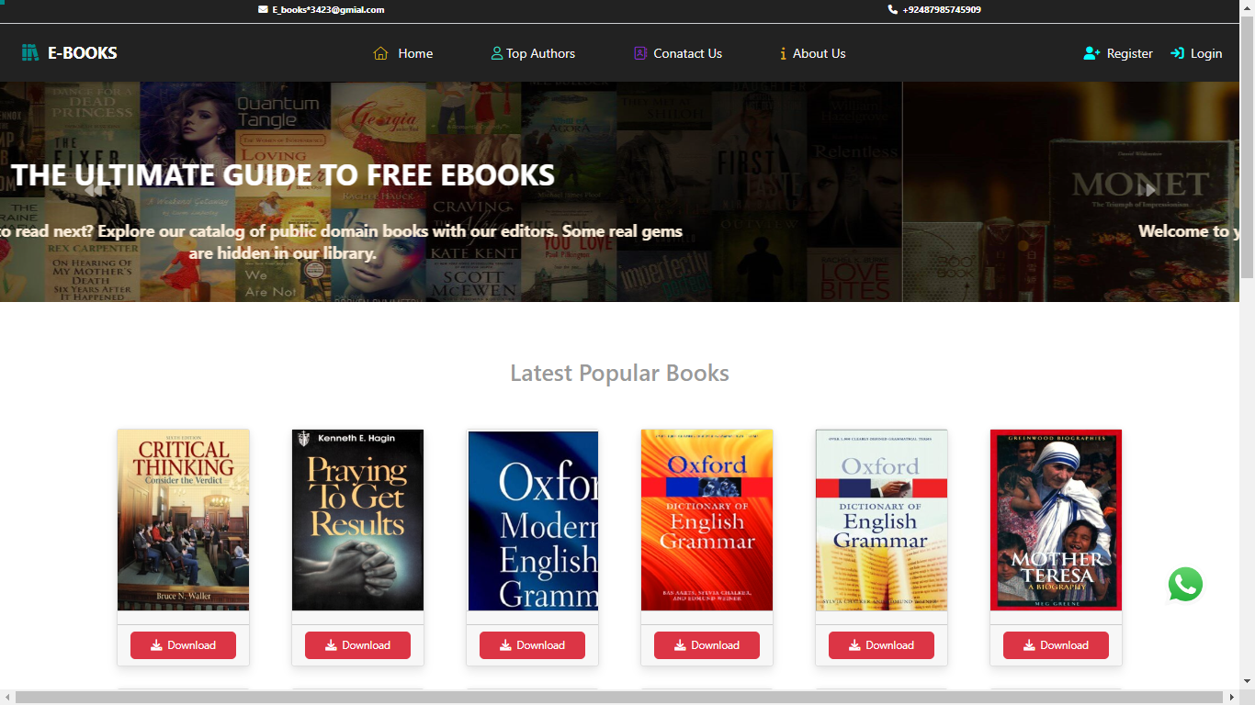

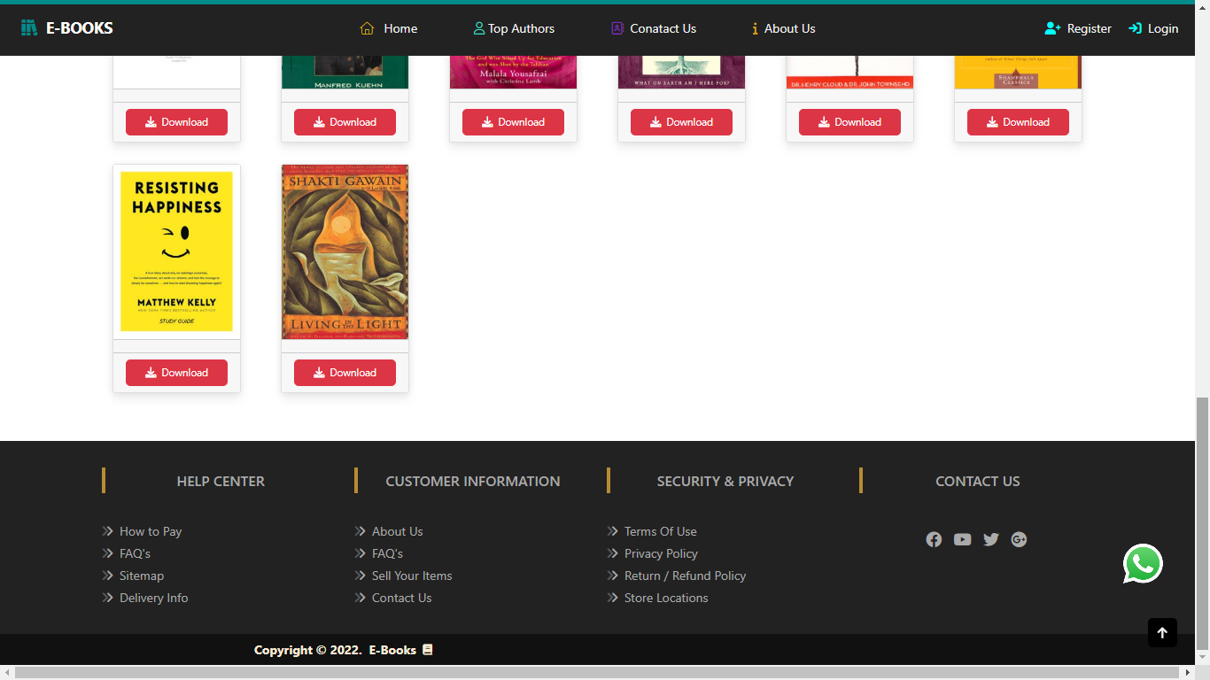

Incorrect Email Or Password

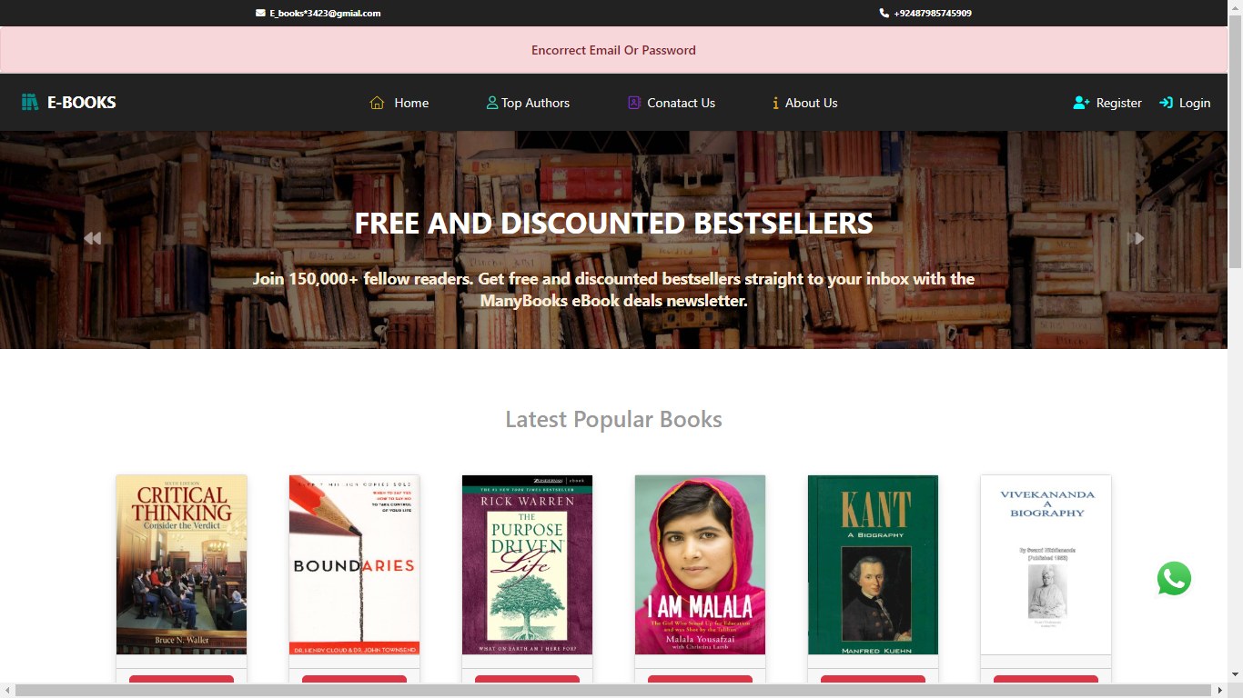

Register User Success Message

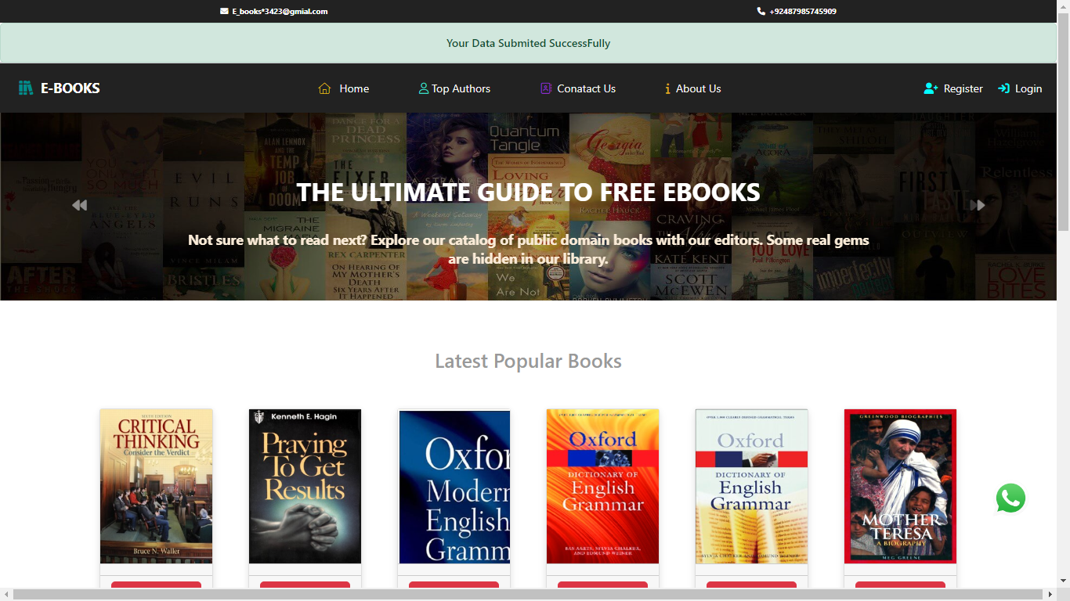

Error Message

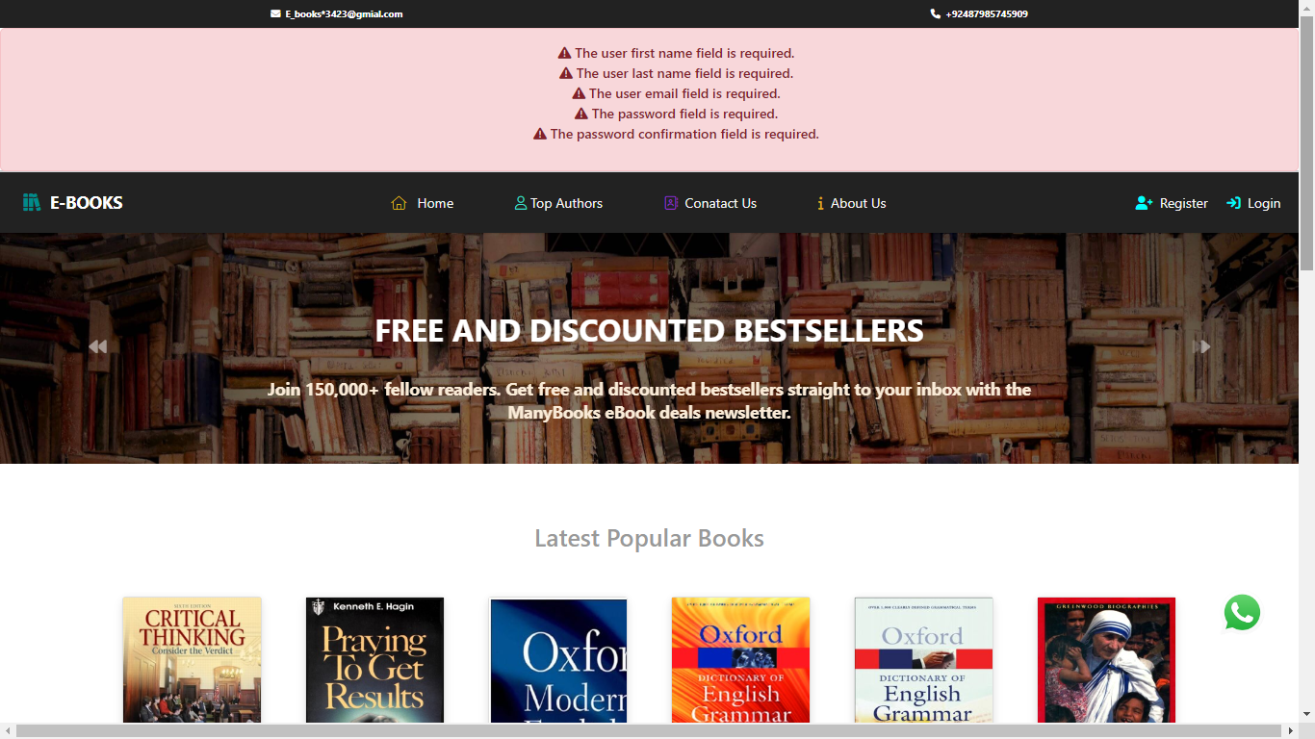

Register User Form

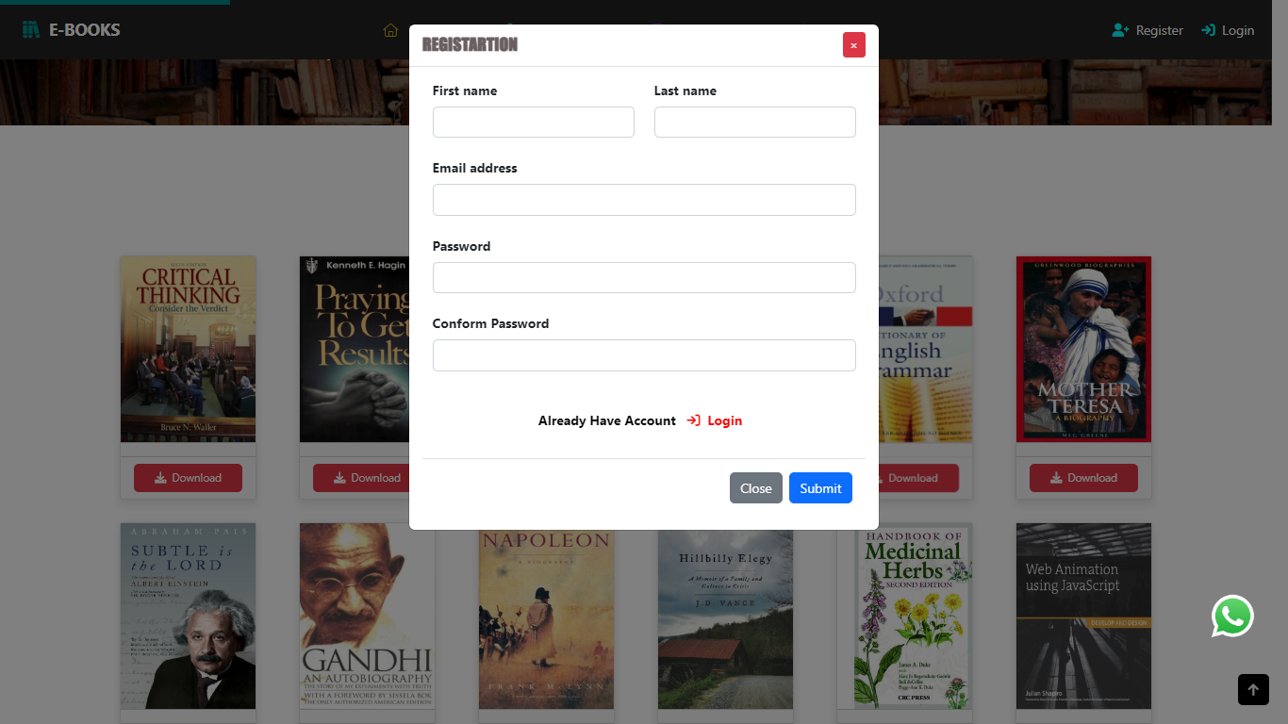

User Logged In View

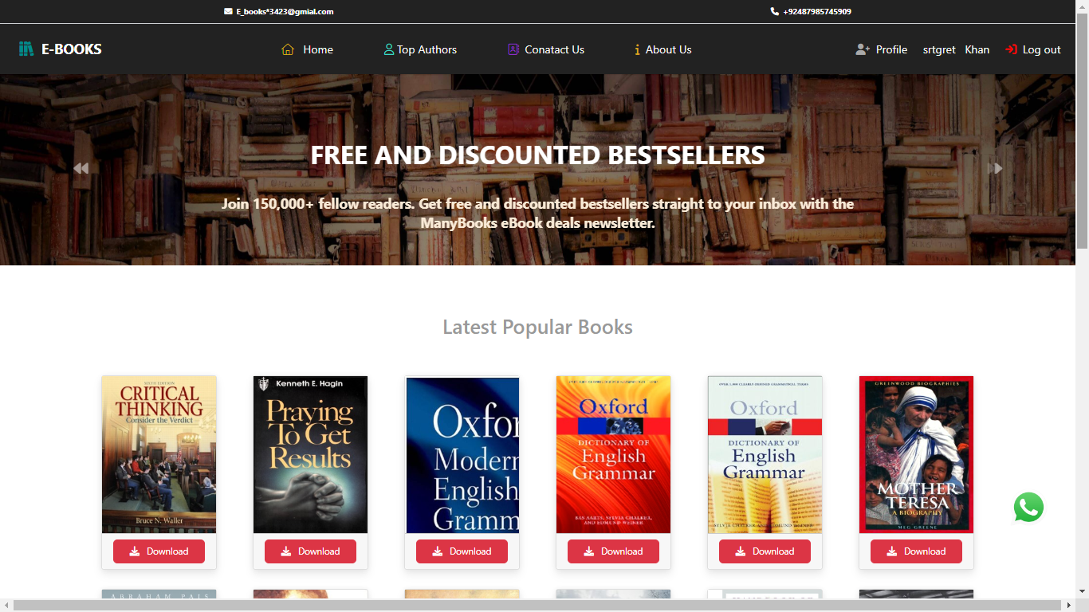

User Profile

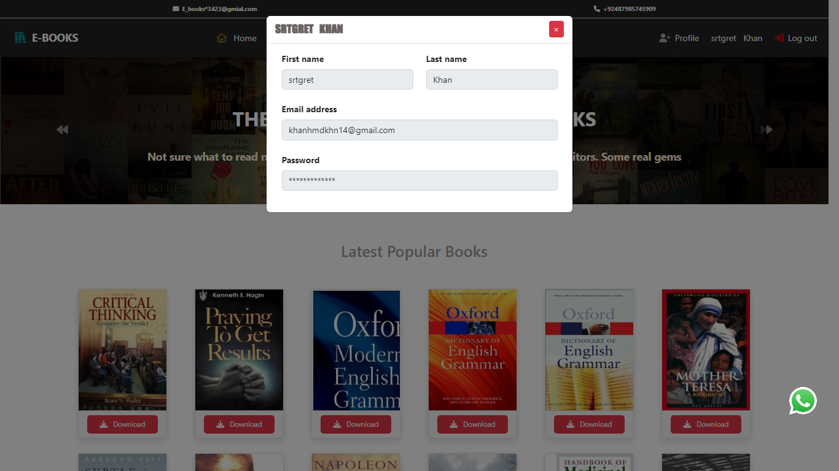

Books Downloads

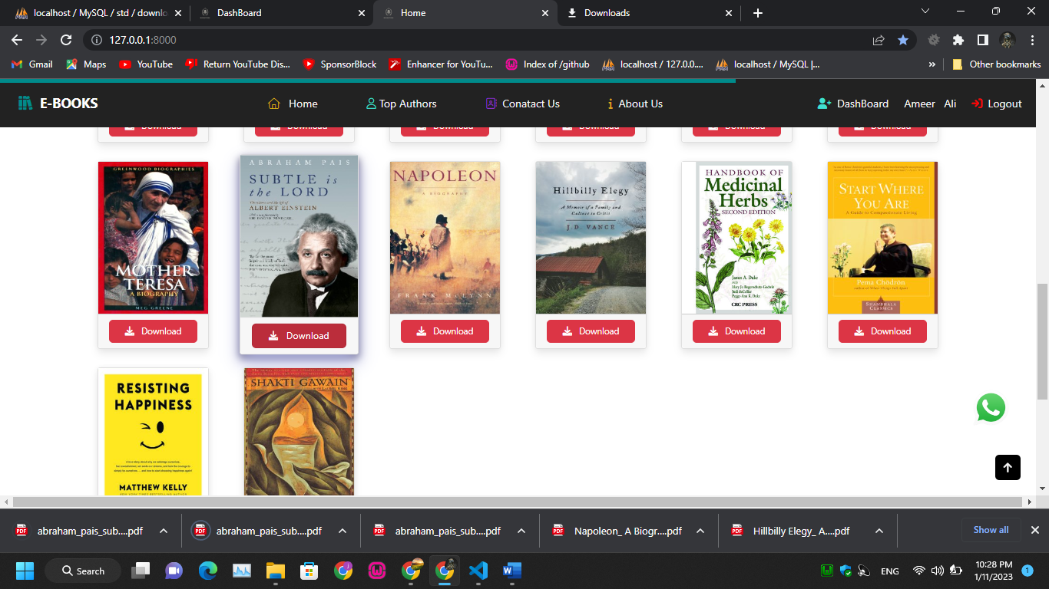

Contact us

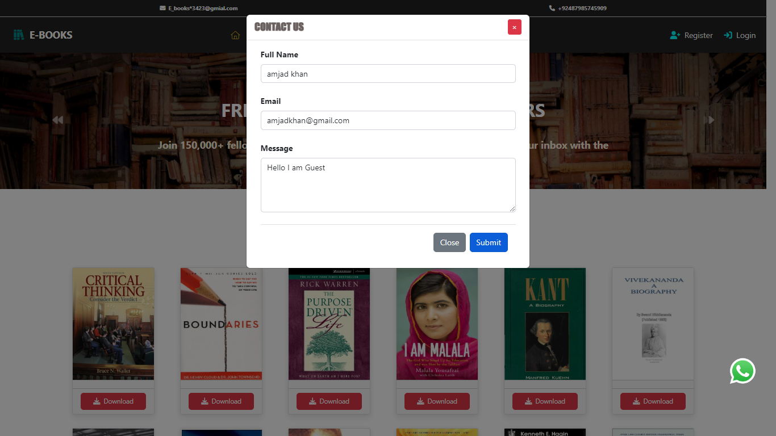

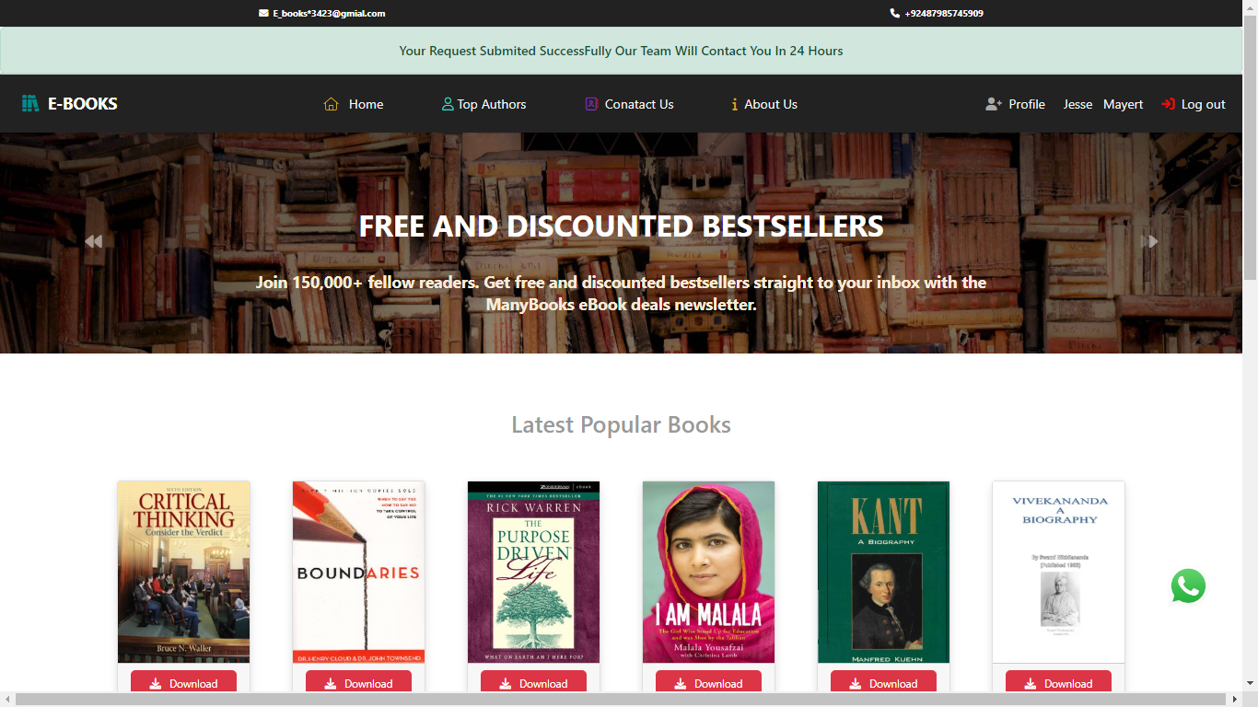

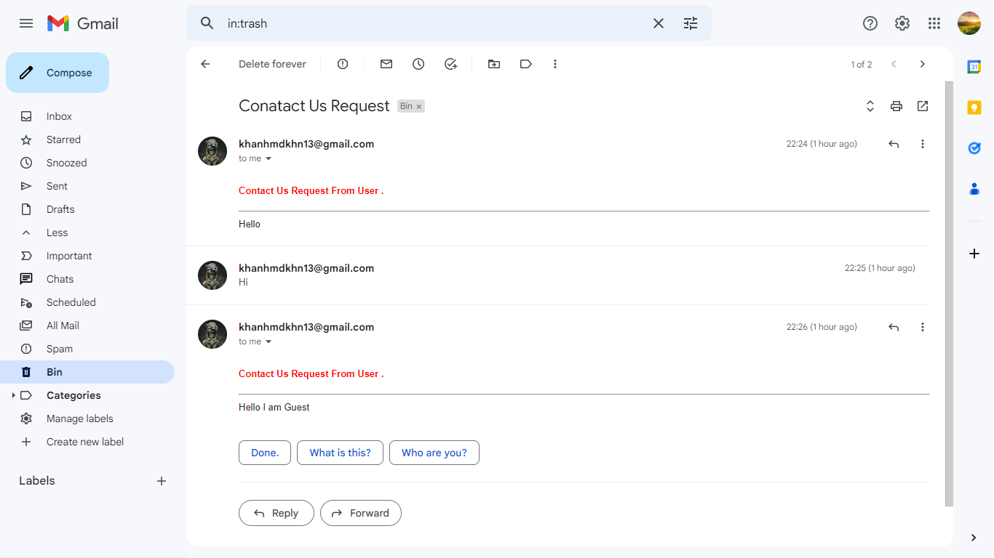

Admin Profile

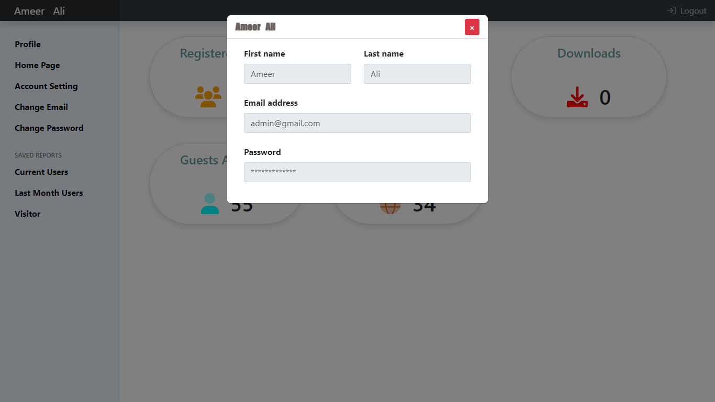

Admin Panel

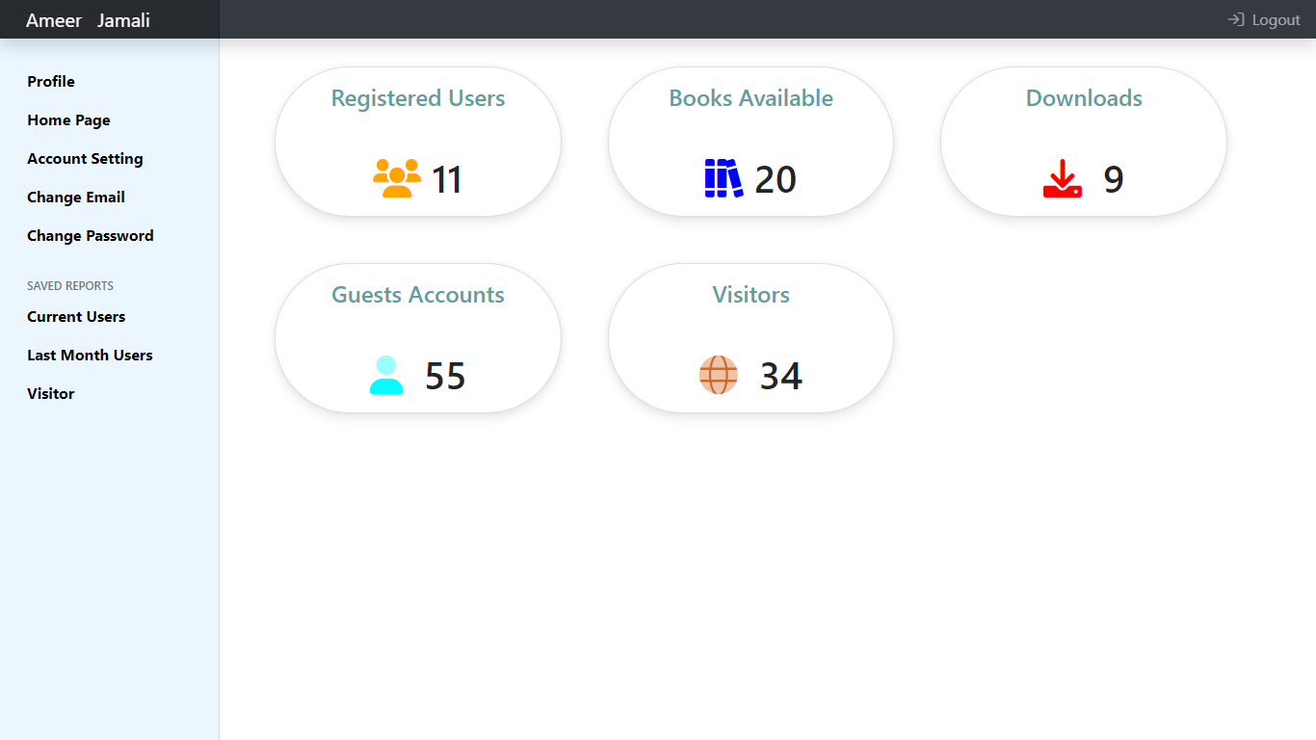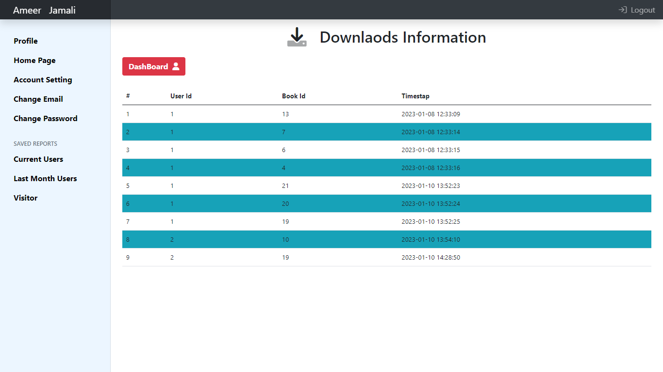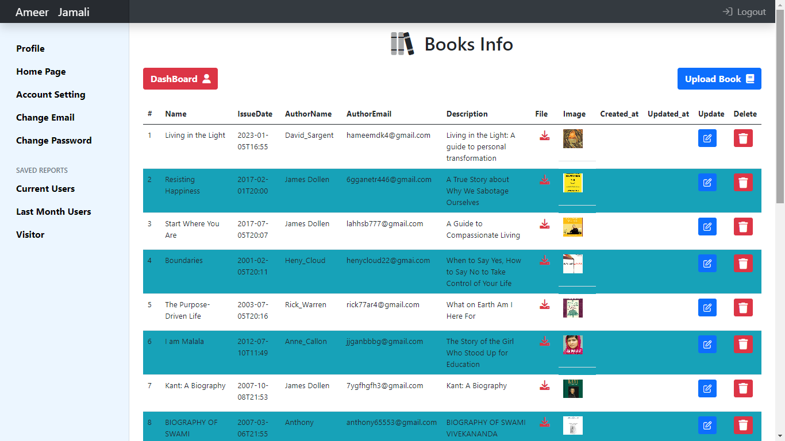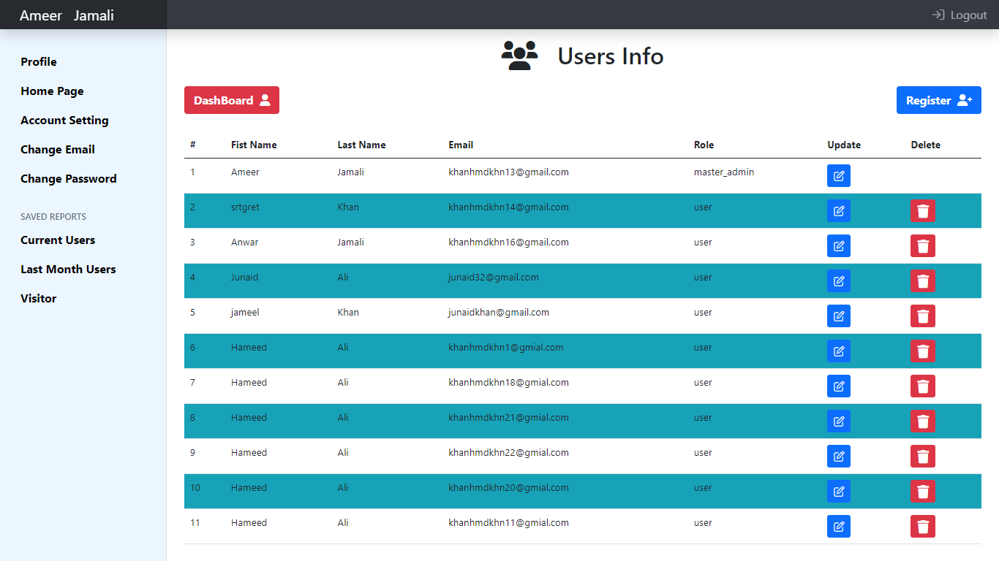

Update User Form

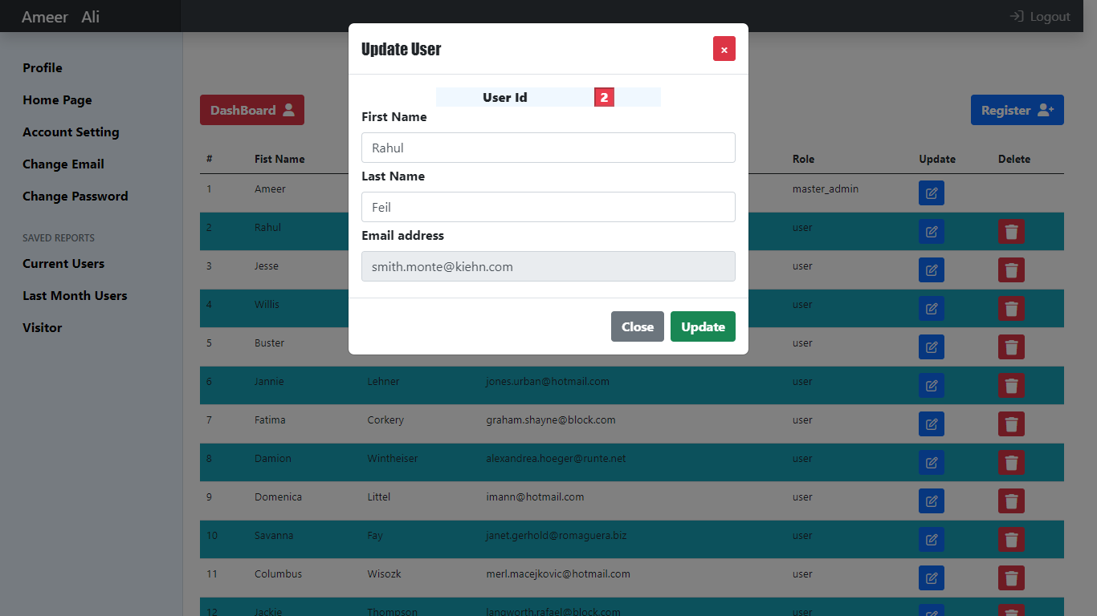

Book Update Form

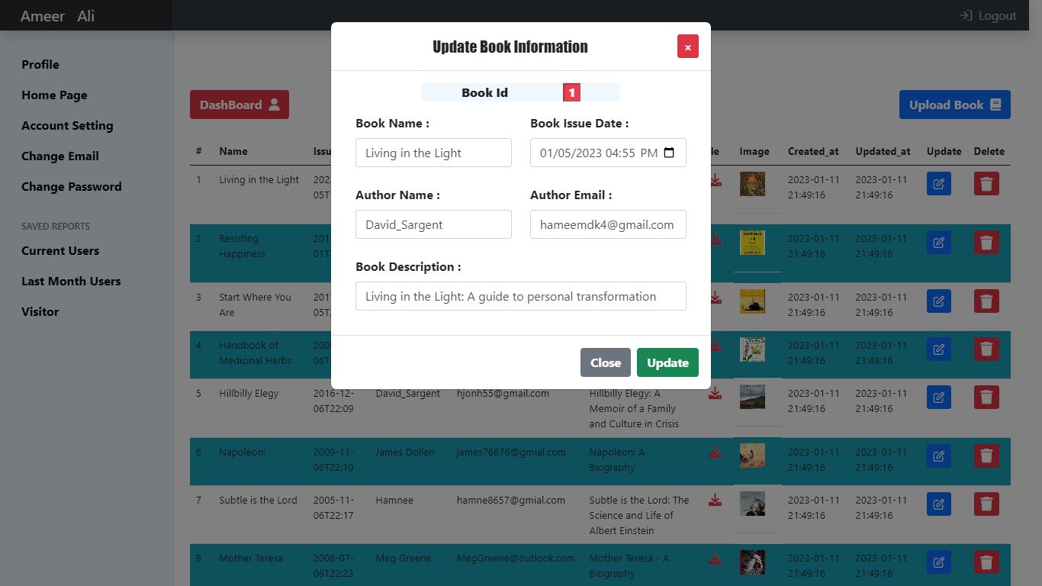

Register User By Admin

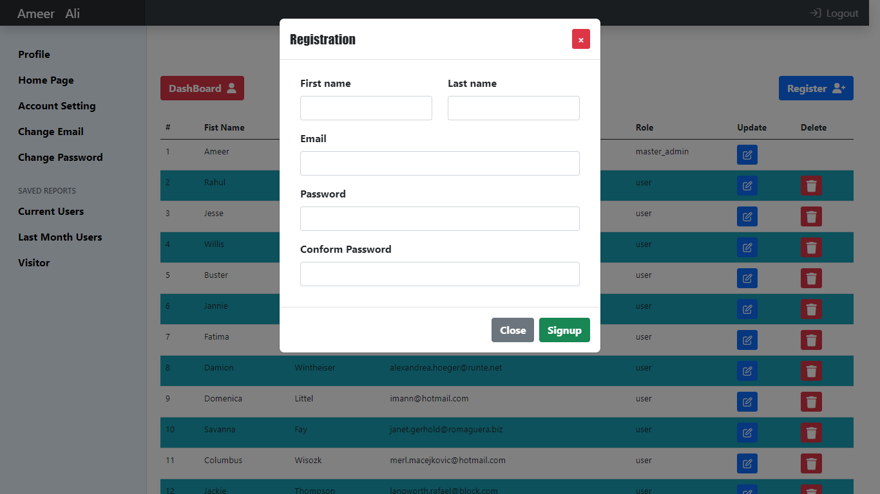

Delete Any Book Or User

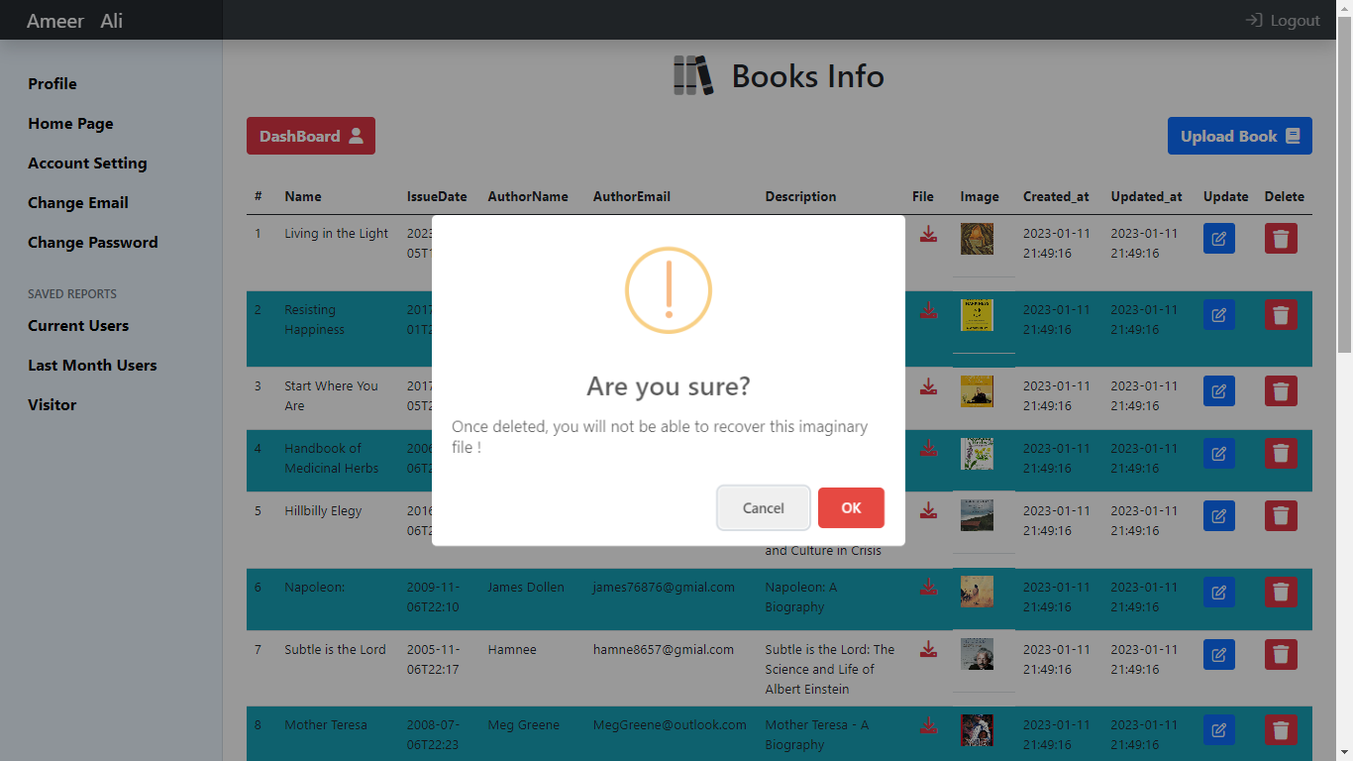

Upload New Book

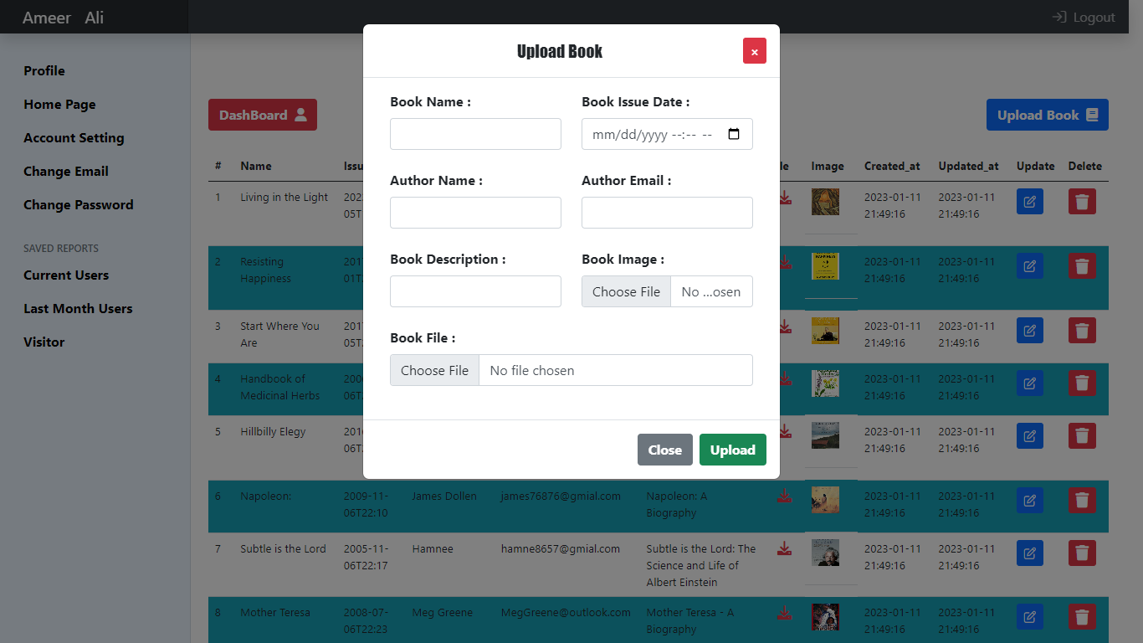

THANK YOU 😊

All Routes Codes

<?php

use Illuminate\Support\Facades\Auth;

use Illuminate\Support\Facades\Route;

use App\Http\Controllers\PdfDownloader;

use App\Http\Controllers\AuthController;

use App\Http\Controllers\MailController;

use App\Http\Controllers\BooksController;

use App\Http\Controllers\UsersController;

/*

|--------------------------------------------------------------------------

| Web Routes

|--------------------------------------------------------------------------

|

| Here is where you can register web routes for your application. These

| routes are loaded by the RouteServiceProvider within a group which

| contains the "web" middleware group. Now create something great!

|

*/

Route::get('/', function () {

    return view('index');

});

Route::get('/userlogout', function () {

    session_abort();

    Auth::logout();

    return redirect('/');

});

Route::get('/adminlogout', function () {

    session_abort();

    Auth::logout();

    return redirect('/');

});

Route::get('/topAuthors', function () {

    return view('topAuthors');

});

Route::any('/', [BooksController::class, 'all_books_home_page']);

Route::get('/adminDashBoard', [AuthController::class, 'get_all']);

Route::post('/userLogin', [AuthController::class, 'login']);

Route::post('/registerUser', [UsersController::class, 'registerUser']);

Route::post('/uploadBook', [BooksController::class, 'upload_book']);

Route::get('/deleteBook', [BooksController::class, 'delete_book']);

Route::get('/deleteUser', [UsersController::class, 'delete_user']);

Route::get('/getUserInfoById/{id}', [UsersController::class, 'get_user_info_by_id']);

Route::get('/getBookInfoById/{id}', [BooksController::class, 'get_book_info_by_id']);

Route::post('/updateUser', [UsersController::class, 'update_user']);

Route::post('/updateBook', [BooksController::class, 'update_book']);

Route::post('/download_pdf', [PdfDownloader::class, 'download_pdf_funciton']);

Route::post('/contactUsRequest', [MailController::class, 'sendRequestToAdmin']);